# RESEARCH PLAN – PROJECT 1 – biomarkers of epileptogenesis after experimental traumatic brain injury

**Figure 1.** PTEgenesis is an evolving target.



1. Significance

Traumatic brain injury (TBI) occurs every 201 seconds in Europe and the USA, and up to 53% of subjects develop epilepsy over the course of their lifetimes11,2,10. Current development of antiepileptogenic (AEG) therapies for patients with the highest risk of epilepsy is seriously impeded by the lack of biomarkers for epileptogenesis to enable the identification of “at risk” individuals14. This applies both to pre-clinical and clinical studies. One critical obstacle in biomarker development is the heterogeneity of clinical patient populations with acquired causes of epilepsy like TBI43. A great advantage of animal models is that one can model a homogeneous pathological type of human condition. In *Project 1*, we will use rats to model temporal lobe TBI, which is the most common site for seizure initiation in post-traumatic epilepsy (PTE) in humans20,21. Similar to any progressive pathology (*e.g.*, Alzheimer’s disease24), epileptogenesis is an “evolving target” (**Fig. 1**), and it is unlikely that a single marker sampled at one time point would provide adequate sensitivity to specifically identify post-traumatic epileptogenesis (PTEgenesis) rather than simply being an indicator of the severity of injury. Therefore, we will collect data from several molecular, structural and functional modalities (plasma, MRI, EEG) over the course of six or 12 months post-TBI, during which we expect about 25% or 50% of animals, respectively, to develop epilepsy27,44. The incidence of PTE is comparable to that expected for the clinical study in *Project 3*, and the follow-up duration is realistic for pre-clinical studies, taking into account the lifespan of rats.

The rat TBI data obtained in *Project 1*, and validated in an independent animal cohort in*Project 2*andin human TBI in *Project 3***,** will provide a biomarker panel for diagnosis of ongoing epileptogenesis after temporal lobe TBI, and enable follow-up of treatment response. Moreover, biomarkers will aid stratification of patients for AEG studies, making human clinical antiepileptogenesis (AEG) trials affordable. For example, it has been calculated that if the risk of PTE in a TBI population could be stratified from 20% to 50%, the cost of a clinical trial would decrease from 18 million to 3.5 million USD14. The biomarker panel developed in *Project 1* can similarly be used for subject stratification and follow-up in preclinical AEG studies. Furthermore, we anticipate our molecular analysis to reveal novel mechanisms of, and the time window for, epileptogenesis. These mechanisms could serve as targets for novel treatments, which – when administered within the optimal time window – would prevent and cure epilepsy.

**Figure 2.** Local generation of pHFOs in an area adjacent to TBI. pHFOs appeared in the perilesional area anterior to the TBI core (ATBI), but not in other areas of neocortex. Black and red traces correspond to wide bandwidth (0.1Hz-3kHz) bandpass filtered signals (100-600Hz). Abbreviations: LFC & RFC – left and right frontal cortex; ATBI, LTBI and PTBI – adjacent areas anterior, lateral & posterior to TBI; CTBI –homotopic site to the TBI in the contralateral hemisphere. Adapted from8.

50ms

**LFC**

**RFC**

**ATBI**

**LTBI**

**TBI**

**PTBI**

**CTBI**

400µV

50µV

2. Innovation

EpiBioS4Rx *Project 1* will be the first statistically powered biomarker study to investigate serially acquired, multimodal in vivo measures [plasma, EEG, structural MRI (sMRI)] in >200 TBI rats, which will allow comparisons between animals that develop epilepsy and those that do not. The molecular, EEG and MRI biomarker platforms developed are novel and clinically translatable. The plasma molecular biomarker analysis will investigate pathology-based hypothesis-driven markers signaling neurodegeneration, neuroinflammation, axonal/dendritic pathology, and metabolic abnormalities (including iron accumulation) which have been proposed alone or in combination to present mechanisms of epileptogenesis and mechanisms of functional impairment in experimental and human TBI38,41. We will investigate whether these markers specifically predict epileptogenesis rather than the severity of injury. We will apply an unbiased approach by performing plasma microRNA-sequencing (miR-seq) and bioinformatics analysis of these data in epileptic and non-epileptic animals to assess the relation of microRNA changes with plasma protein findings and discover novel mechanisms and biomarker. The microstructural imaging will align with the molecular analyses, being tuned to detect neurodegeneration, inflammation, axonal damage, and iron depositions. As a gold-standard outcome measure we will use occurrence of spontaneous seizures, but we will also test whether pathological high-frequency oscillations (pHFOs) or repetitive HFOs and spikes (rHFOSs) will provide an earlier marker for epileptogenesis (**Fig. 2)**.

We will use a standardized rat model of closed-head moderate to severe TBI. We have developed inclusion and exclusion criteria for parallel clinical investigations to permit correlative animal/human research paradigms, where pilot data obtained from animal experiments are being used to develop hypotheses for clinical investigations. We will contribute to the first preclinical epilepsy database managed in the *Informatics and Analytics Core (IAC),* providing large amounts of plasma molecular, EEG, and MRI data for development of high-throughput pipeline methodologies for biomarker discovery. We will design harmonized protocols which enhance the reproducibility of research findings through increased scientific rigor and transparency. This is achieved by using the *common data elements (CDEs)* and guidelines recently developed for preclinical epilepsy and TBI research as templates, tailored to the needs of EpiBioS4Rx, harmonizing data collection, procedures applied, and data analysis. Data collected will become available to the research community from the *IAC*. This will set the stage for data-mining and large preclinical multicenter studies beyond the epilepsy field.

Unlike in previous studies, we will not expect the same biomarker to work in every subject at a given time point, as the location and progression of pathology varies from one individual to another. Our biomarker detection strategy is novel as it (a) takes into account the brain network damaged in a given subject and (b) applies the lesion extent, severity, and type (inflammatory vs. no inflammation; iron vs. no iron) detected with sMRI at a given time point to *stage epileptogenesis* in a given animal. Consequently, biomarker analyses will be done relative to both time after TBI and to injury stage in sMRI (*e.g.*, animals with 6 mm3 cortical lesion vs. 3 mm3 lesion) independent of post-injury time. In parallel, we will consider a possibility that identification of specific extratemporal damage after temporal lobe TBI increases the sensitivity of a biomarker panel for epileptogenesis, which is primarily composed of structural and electrophysiological indicators of temporal lobe pathologies.

Most of the previous biomarker studies in TBI have focused on identification and use of a single biomarker56. We will focus our search on identification of a combinatory biomarker panel which combines information related to a given pathology from different analysis modalities (e.g., combination of plasma and MRI markers of neurodegeneration, axonal/dendritic injury, neuroinflammation, and metabolic disturbance and concomitant occurrence of pHFOs and rHFOSs in EEG).



**Figure 3**. Imaging of hippocampal and thalamic pathway damage and its histologic validation. Magnetization transfer ratio (MTR) and DTI from a TBI rat 6 months after lateral FPI. **(A)** MTR images *in vivo* and **(B)** *ex vivo*. White arrows point to damage in the ipsilateral internal capsule (IC). Myelin staining of ipsilateral **(C)** and contralateral **(D)** internal capsule. Black arrow indicates loss of myelinated axons in IC. DTI images of the same rat *in vivo* **(E)** and *ex vivo* **(F)**. White arrows indicate thinning of the fimbria ipsilaterally. Myelin staining of the fimbria ipsilaterally **(G)** and contralaterally **(H)**. Scale bar: 1 mm.

*Project 1* investigators have pioneered the development and long-term characterization of animal models of PTE in rodents and chronic assessment of these models using multimodal in vivo approaches, and are internationally recognized for this. The PIs have extensive complementary experience in molecular analyses, long-term video-EEG (vEEG) monitoring, and in vivo neuroimaging, which are critical methodologies in assessment of disease phenotype in epileptogenesis studies39. All three involved centers have state-of-the-art imaging facilities for rodents and a proven track record demonstrated by publications5,22,26,28,29,31,39,40,44,46. The investigators’ complementary expertise spans the various aspects of this project (Pitkänen - modeling, functional neuroanatomy, molecular analysis; Bragin – electrophysiology; O’Brien, Jones and Shultz – animal models of epilepsy and TBI, in vivo electrophysiology, molecular analysis, imaging; Gröhn, Harris, Johnston – imaging). O’Brien and Staba also work with patients, ensuring the experiments in this project have a direct translational perspective.

Consultants for *Project 1* will guarantee rigor in the use of state-of-the-art molecular (Henshall – microRNA; Paananen – bioinformatics) and electrophysiological (Bragin, Mody) analysis protocols as well as critical interpretation of data obtained.

We have also planned *the next steps*. The findings of the animal model will be validated in an independent rat cohort in *Project 2* and a human clinical cohort in *Project 3*, and applied in a multicenter preclinical antiepileptogenesis trial in *Project 2*. Additionally, the investigators of *Project 1* will work together with the *Public Engagement Core* to anticipate the subjective, ethical, and social consequences for subjects being informed of the risk of epileptogenesis after TBI based on biomarker analysis.

3. Approach

*Project 2* preliminary data suggests the temporal lobes to be the location of TBI most likely to result in PTE in humans; 20,21). To model this clinical situation, we will induce severe TBI to the temporal cortex in rats using lateral fluid-percussion injury (FPI). Lateral FPI is a commonly used model of closed-head injury in humans33 which results in epilepsy in about 50% of rats in a one-year follow-up27,44. We will adjust the location of lateral FPI impact to cause damage to temporal lobe regions which are homologous to those in humans known to pose greatest risk of PTE: the lateral temporal cortex, temporal pole, perirhinal and entorhinal cortices, parahippocampal gyrus (areas TH, TF), and hippocampus9. In addition, like in humans, there is thalamic damage (**Figs. 3, 6**). Thus, lateral FPI results in distribution of pathologies that are the most common in human PTE. InSpecific Aim 1wewill assess whether specific EEG changes (pHFOs, rHFOSs) **(Figs. 2, 4; Appendix 2**8**)** in the perilesional temporal and extratemporal cortex and/or in the septal hippocampus provide sensitive and specific biomarkers for PTEgenesis. In Specific Aim 2 we will investigate underlying microstructural changes in hippocampal (perforant pathway, fimbria-fornix) and thalamo-cortical pathways (capsula interna) using sMRI sensitive for detection of neurodegeneration, axonal/myelin pathology (**Figs. 3, 7, 8**), inflammation, and iron accumulation **(Fig. 10)**, and whether specific pathologies can be used as biomarkers for post-traumatic epileptogenesis (PTEgenesis). Speficic Aim 3 will assess whether specific changes in 15 plasma proteins and microRNA which signal about neuronal and glial degeneration, neuroinflammation, axonal/dendritic damage, and metabolic changes will provide useful biomarkers for PTEgenesis. In unbiased RNA-seq analysis we will apply advanced bioinformatics tools to discover novel candidate plasma biomarkers beyond the above pathologies.

**Figure 4.**  **(A)** An example of rHFOS recorded anterior to TBI (ATBI) and normal spindle that coincidently occurred in the area contralateral to the TBI core (CTBI). **(B)** Another example of wide bandwidth (0.1 Hz -3 kHz) recorded rHFOS with population spike at onset (dashed box). B1) Expanded trace of population spike (bottom) and 500 Hz highpass filtered trace that contains multiunit activity (top). Abbreviations same as Fig. 7. Adapted from8.

0.25s

0.5mV

**LFC**

**RFC**

**LTBI**

**ATBI**

**TBI**

**PTBI**

**CTBI**

normal sleep spindle

rHFOS

**A**

0.1mV

0.5mV

5ms

0.5mV

0.5 s

**B**

**B1**

In the end of the Year 3, we will combine data from plasma markers, EEG and structural MRI (sMRI), and test the biomarker value of different parameters alone and in combination. Then, the animal biomarkers will be compared to human biomarkers of PTEgenesis from *Project 3.*The most predictive animal biomarker panelwill be validated in an independent cohort in *Project 2*and tested for prediction of treatment response in *Project 2*(Years 4-5).

3.1. Specific Aim 1: (1) To investigate the occurrence and progression of abnormalities in cortical and hippocampal wideband EEG recordings acquired immediately after temporal lobe TBI for up to 12 months post-injury; (2) To compare the severity and progression of changes between animals that will or will not develop epilepsy; (3) To provide a set of candidate biomarkers to be validated in an independent animal cohort in *Project 2* and human cohort with temporal lobe TBI in *Project 3;* (4) To assess whether a combination of imaging and plasma markers increases the sensitivity and specificity of electrophysiological markers.

3.1.1. Hypothesis 1***:*** Temporal lobe TBI in the rat will result in electrophysiological abnormalities in the perilesional cortex and hippocampus, some of which will be biomarkers for epileptogenesis both in animals and humans. Integration with concomitant molecular and structural abnormalities will increase the sensitivity and specificity of electrophysiological biomarkers.



**Figure 5**. Randomization and expected animal numbers. The animal cohort consists of 189 rats from which 161 are randomized to TBI and 28 to sham-operation. After acute mortality (30% expected), follow-up cohort consists of 140 rats (112 TBI, 28 sham-operated). After expected 25% follow-up mortality, we will have 21 TBI rats with epilepsy, 63 TBI rats without epilepsy, and 21 sham-operated controls. To achieve this, follow-up of animals is divided equally between the 3 sites (Kuopio, Melbourne, UCLA), each producing at least 7 TBI rats with epilepsy, 21 without epilepsy, and 7 sham-operated animals.

Preliminary results to support Hypothesis 1 – Electrophysiology: Recent published work from UCLA8 (**Appendix 2**) found pHFOs in cortical areas within or adjacent to injury site of 58% of TBI rats (n=12), but none in controls (n=14; **Fig. 2**). All pHFOs were detected between two and seven days after TBI. In these same areas within three days after the appearance of pHFOs, paroxysmal activity was found consisting repetitive pHFOs and EEG spikes (rHFOSs) in a 10-16 Hz arcuate-shaped pattern (**Fig. 4**). The EEG spike component of rHFOSs had a mean duration of 25±11 ms and corresponded with an increase in neuronal spike firing (**Fig. 4B**). In addition, immediately after injury 83% of TBI rats had paroxysmal delta (1-3 Hz) activity that had maximum amplitude within and near the injury site, but normalized within 96 h of injury and likely associated with non-specific changes in the extracellular ionic and neurochemical milieu (data not shown). However, four rats that had pHFOs and rHFOSs within the first two weeks later developed seizures, whereas as none of the rats without these events developed late seizures.

**3.1.2. Experimental Design:** Electrophysiology to detect functional abnormalities in hippocampal and thalamo-cortical networks:To align with *Project 3,* assess EEG abnormalities during the first week beginning immediately after TBI. To extend the clinical follow-up, we will continue EEG monitoring for up to 12 months.

**Figure 6.** Study design: SA1. Lateral FPI -induced temporal lobe injury. **(A)** Location of craniotomy and EEG recording electrodes (red dots). Blue dashed lines show the levels of MRIs in panels B and C, **(BB)** Typical lesion at 3 months after lateral FPI. The lesioned areas include perirhinal cortex (PRCx), auditory and visual association cortices (A and V Cx), and extends caudally to postrhinal cortex [PoRCx; Panel **(BC)**]**.** Thus, the lesioned regions correspond to temporopolar cortex, parahippocampal gyrus and lateral temporal cortex in the humans with PTE**5**. Note ipsilateral atrophy in the hippocampus (HC) and thalamus (T). Ab, angular bundle (performant pathway). Grid square in A 1 mm2. **(C) T**o align with clinical study, electrodes will be implanted right after FPI and vEEG recording will be continued for 12 months, after which animals will be perfused for *ex vivo* MRI. To align with SA2, we will sample blood at corresponding time points (red dots).



3.1.3. Protocol and data collection:The firstcohort of 189 adult male Sprague-Dawley rats (63 per study site) will be randomized to the sham-injury or FPI condition (**Fig. 5**). Anesthetized animals will be injured with temporal lobe FPI, and intracortical, intrahippocampal and contralateral cortical epidural electrodes (**Fig. 6A**) will be implanted at the same surgery session. The electrodes will be connected to the input of operational amplifiers via cable connectors, and vEEG will be monitored 24/7 for the week post-injury. Thereafter, we will monitor rats in 48-h epochs once a month as shown in **Fig. 6C**. EEG activity (0.1-600 Hz) will be sampled at 2 kHz/channel with each center’s own data acquisition system. All data will be stored on hard drives for off-line analysis and uploaded to the *IAC*where the data will be converted to a standardized common data format. The *IAC*will also include all experimental meta-information, and provide easy querying over the imported data. To align with Specific Aim 2, venous blood will be collected from tail vein before TBI and at 4 post-TBI time points (**Figs. 6, 9**) for plasma protein and microRNA analysis. Terminally, rats will be perfusion-fixed for ex vivo MRI and brains will be stored in a biobank for later analysis, if the need arises.

3.1.4. Data Analysis***:*** Electrographic events will be detected and analyzed from wide bandwidth recordings (0.1-600 Hz) at each electrode site using a combination of manual review and algorithms written in Matlab. To detect seizures we will first compute a feature set consisting commonly used measures of line length, area, energy, and zero crossing18 from manually detected seizures to train a linear discriminant classifier, and then detect seizures within continuous recordings. Preliminary work in six TBI rats showed this approach could detect seizures within 2.5±1.2 sec of onset, but more importantly with reasonably high sensitivity (mean 82%; min-max: 45-100%) and expectedly moderate specificity (46%; 6-88%). All detected events will be verified with expert review. Rats with at least one late spontaneous electrographic seizure (>10 sec) occurring after the first post-TBI week will be included in the epilepsy group17. For detection of pHFOs, rHFOSs, EEG spikes, and variants of these events (e.g. polyspike and wave) we will use an approach28 that compares energy of signal to an energy threshold and has been used by us and others25,29–35. Each type of event will be detected from bandpass filtered signal as follows: EEG spikes (1-30 Hz), rHFOS (8-20 Hz), pHFOs (100-600 Hz). Information recorded about each seizure will include (a) time of occurrence (delay from TBI, day/night), (b) location of seizure relative to the injury site (ipsilateral, contralateral or bilateral), and (c) where among the electrode sites the seizure begins and spreads. For analysis of each EEG event, we will first select from the daily recordings (*i.e*., 24-h day) two 20-minute epochs of EEG corresponding to behavioral waking immobility and sleep slow wave activity during the first, middle, last 8-hour period (total 120 min/d). Length of recording to analyze will be determined in part by rate of pHFOs and rHFOSs in TBI rats (3.1±0.9 and 5.0±1.8 per minute, respectively). Then for each event at each electrode site we will measure the following: total number of events, rate of occurrence per minute, central tendency of inter-event interval histogram, mean and total event duration, and total mean and/or peak spectral frequency. In addition, we will compute the power ratio between the following spectral frequency bands: delta (1-3Hz) & theta (4-8Hz), delta & gamma (30-90 Hz), and theta & gamma to identify spatial and temporal changes in power associated with pathophysiology of TBI and those changes associated with epileptogenesis. The data will be compared primarily between TBI epilepsy *vs.* TBI no-epilepsy groups. To decide the biomarker value of each parameter for diagnosing epileptogenesis correctly, area under curve (AUC), sensitivity, and specificity will be assessed using ROC analysis for each parameter alone and in combination with other measures. Age-related EEG changes will be analyzed from the sham-operated group.

3.1.5. Anticipated results: We will be able to define (a) the latency from TBI to PTE, (b) the evolution of EEG changes during PTEgenesis, (c) the progression of EEG changes between 6 and 12 months. We also anticipate that abnormalities will be most prominent ipsilateral to the injury site. Based on our preliminary data we expect that epileptogenic TBI rats will have increased rate of occurrence, amplitude, duration, and power of HFOs and rHFOS, gradually increasing number of epileptiform EEG spikes and their variants, and significant differences in gamma power with respect to power of the other EEG frequency bands as compared to non-epileptogenic TBI rats. The appearance of epileptiform patterns will correlate with abnormalities in other functional tests. Some of the EEG parameters will be sensitive and specific biomarkers for epileptogenesis alone or in combination with measures from other analysis modalities.

3.2. Specific Aim 2: (1) To characterize structural pathology in the cortex, hippocampus, and thalamus and in their connectivity after temporal lobe TBI using repeated high-resolution anatomical and microstructural MRI and selective histologic staining (neurodegeneration, axonal/myelin injury, neuroinflammation, and iron accumulation). (2) To compare findings between animals which develop or do not develop epilepsy.

3.2.1. Hypothesis 2***:*** Temporal lobe TBI in the rat will result in structural pathology in septo-hippocampal, entorhinal-hippocampal, and thalamocortical networks. Pathologies and their temporal evolution will be most prominent in hippocampal networks, and some of them will be useful biomarkers for epileptogenesis. The presence of extratemporal pathologies, evolution of abnormalities in electrophysiological and/or plasma markers will increase the sensitivity and specificity of imaging biomarkers.

Preliminary results to support Hypothesis 2 – Imaging: 3.1 Temporal lobe FPI results in microstructural changes in hippocampal and extrahippocampal pathways which can be detected with microstructural MRI. The gross pathological imaging of brain damage using, e.g., volumetry or T2-weighted imaging gives little information about microstructural changes. Therefore, we will apply more sophisticated in vivo imaging techniques.

DTI: Data obtained in Kuopio demonstrated significant DTI changes in different hippocampal subfields, including angular bundle and fimbria-fornix after TBI, which were histologically verified to indicate subfield specific changes in myelin integrity (Fig. 245). Unpublished DTI data indicated changes in corpus callosum, fimbria-fornix, and capsula interna. Recently, the group in Kuopio collected data from 5 controls and 6 rats with TBI at 5 months post-TBI, and conducted a preliminary study exploiting phase contrast and magnetization transfer (MT) MRI. Data indicated changes in these parameters as compared to DTI, demonstrating higher sensitivity of MT than DTI to demyelination and high sensitivity of phase contrast or susceptibility weighted imaging (SWI) to iron. Diffusion MRI tractography: Tractography offers increased specificity to localized and inter-structural changes in diffusion characteristics over traditional DTI metrics (Figs. 7, 8). Data from Melbourne demonstrated structural connectivity changes after lateral FPI in areas implicated in epileptogenesis, including the perilesional cortex and hippocampus (**Fig. 7**). Tractography also allows generation and analysis of specific inter-structural pathways, as demonstrated by the analysis of the corticospinal tract which revealed post-FPI changes in cortico-spinal tract density (**Fig. 8**). These initial data demonstrate the feasibility of using tractography techniques in analysis of intra- and inter-structural network changes for comparison of severity and distribution of pathologies in TBI rats with and without epilepsy.

Analysis of MRI data from different sites in IAC (P20 grant). We recently placed datasets from TBI rats injured in Kuopio or Melbourne to IAC cloud. This pilot project created the pipeline for data transfer and image format transformations needed and shows the feasibility to analyze preclinical data in IAC.

**Figure 7.** Whole-brain tractography reveals changes in several structures implicated in epileptogenesis, including the perilesional cortex (Ctx) and hippocampus (Hc), in rats with FPI **(B)** compared to sham-injured **(A)**.

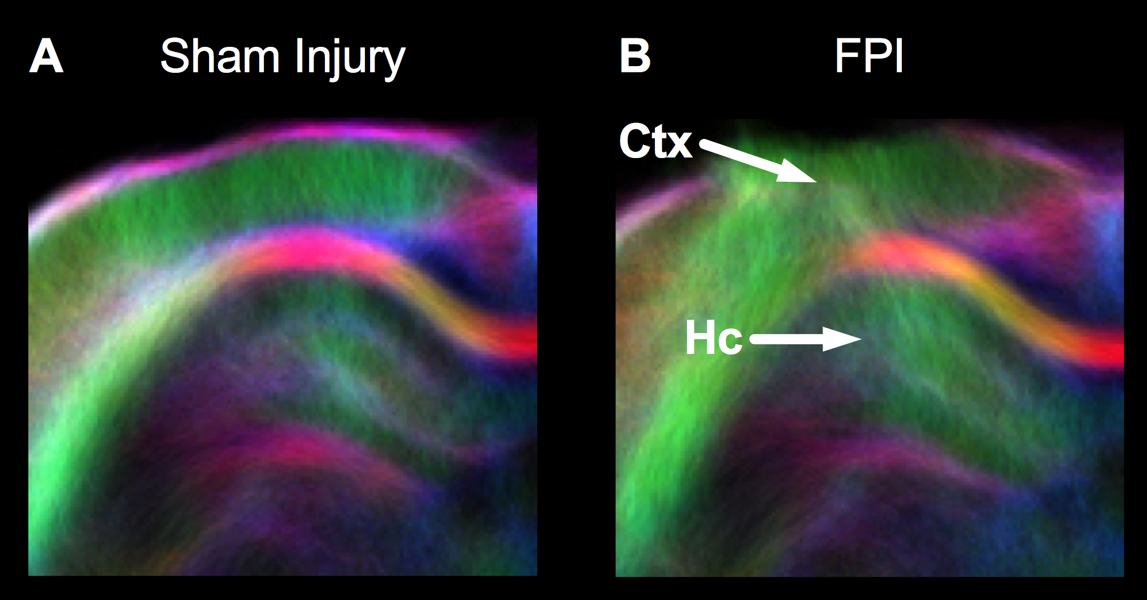

**Figure 8**. (A) The location of seed (motor cortices, pink) and target (pons, yellow) regions used to generate the corticospinal tract (CST; B). (C) Voxel-based analysis within the CST revealed voxels of reduced tract density in rats with FPI compared to sham-injured rats, which are indicated in orange. This approach could be used to assess connectivity between structures implicated in epileptogenesis.

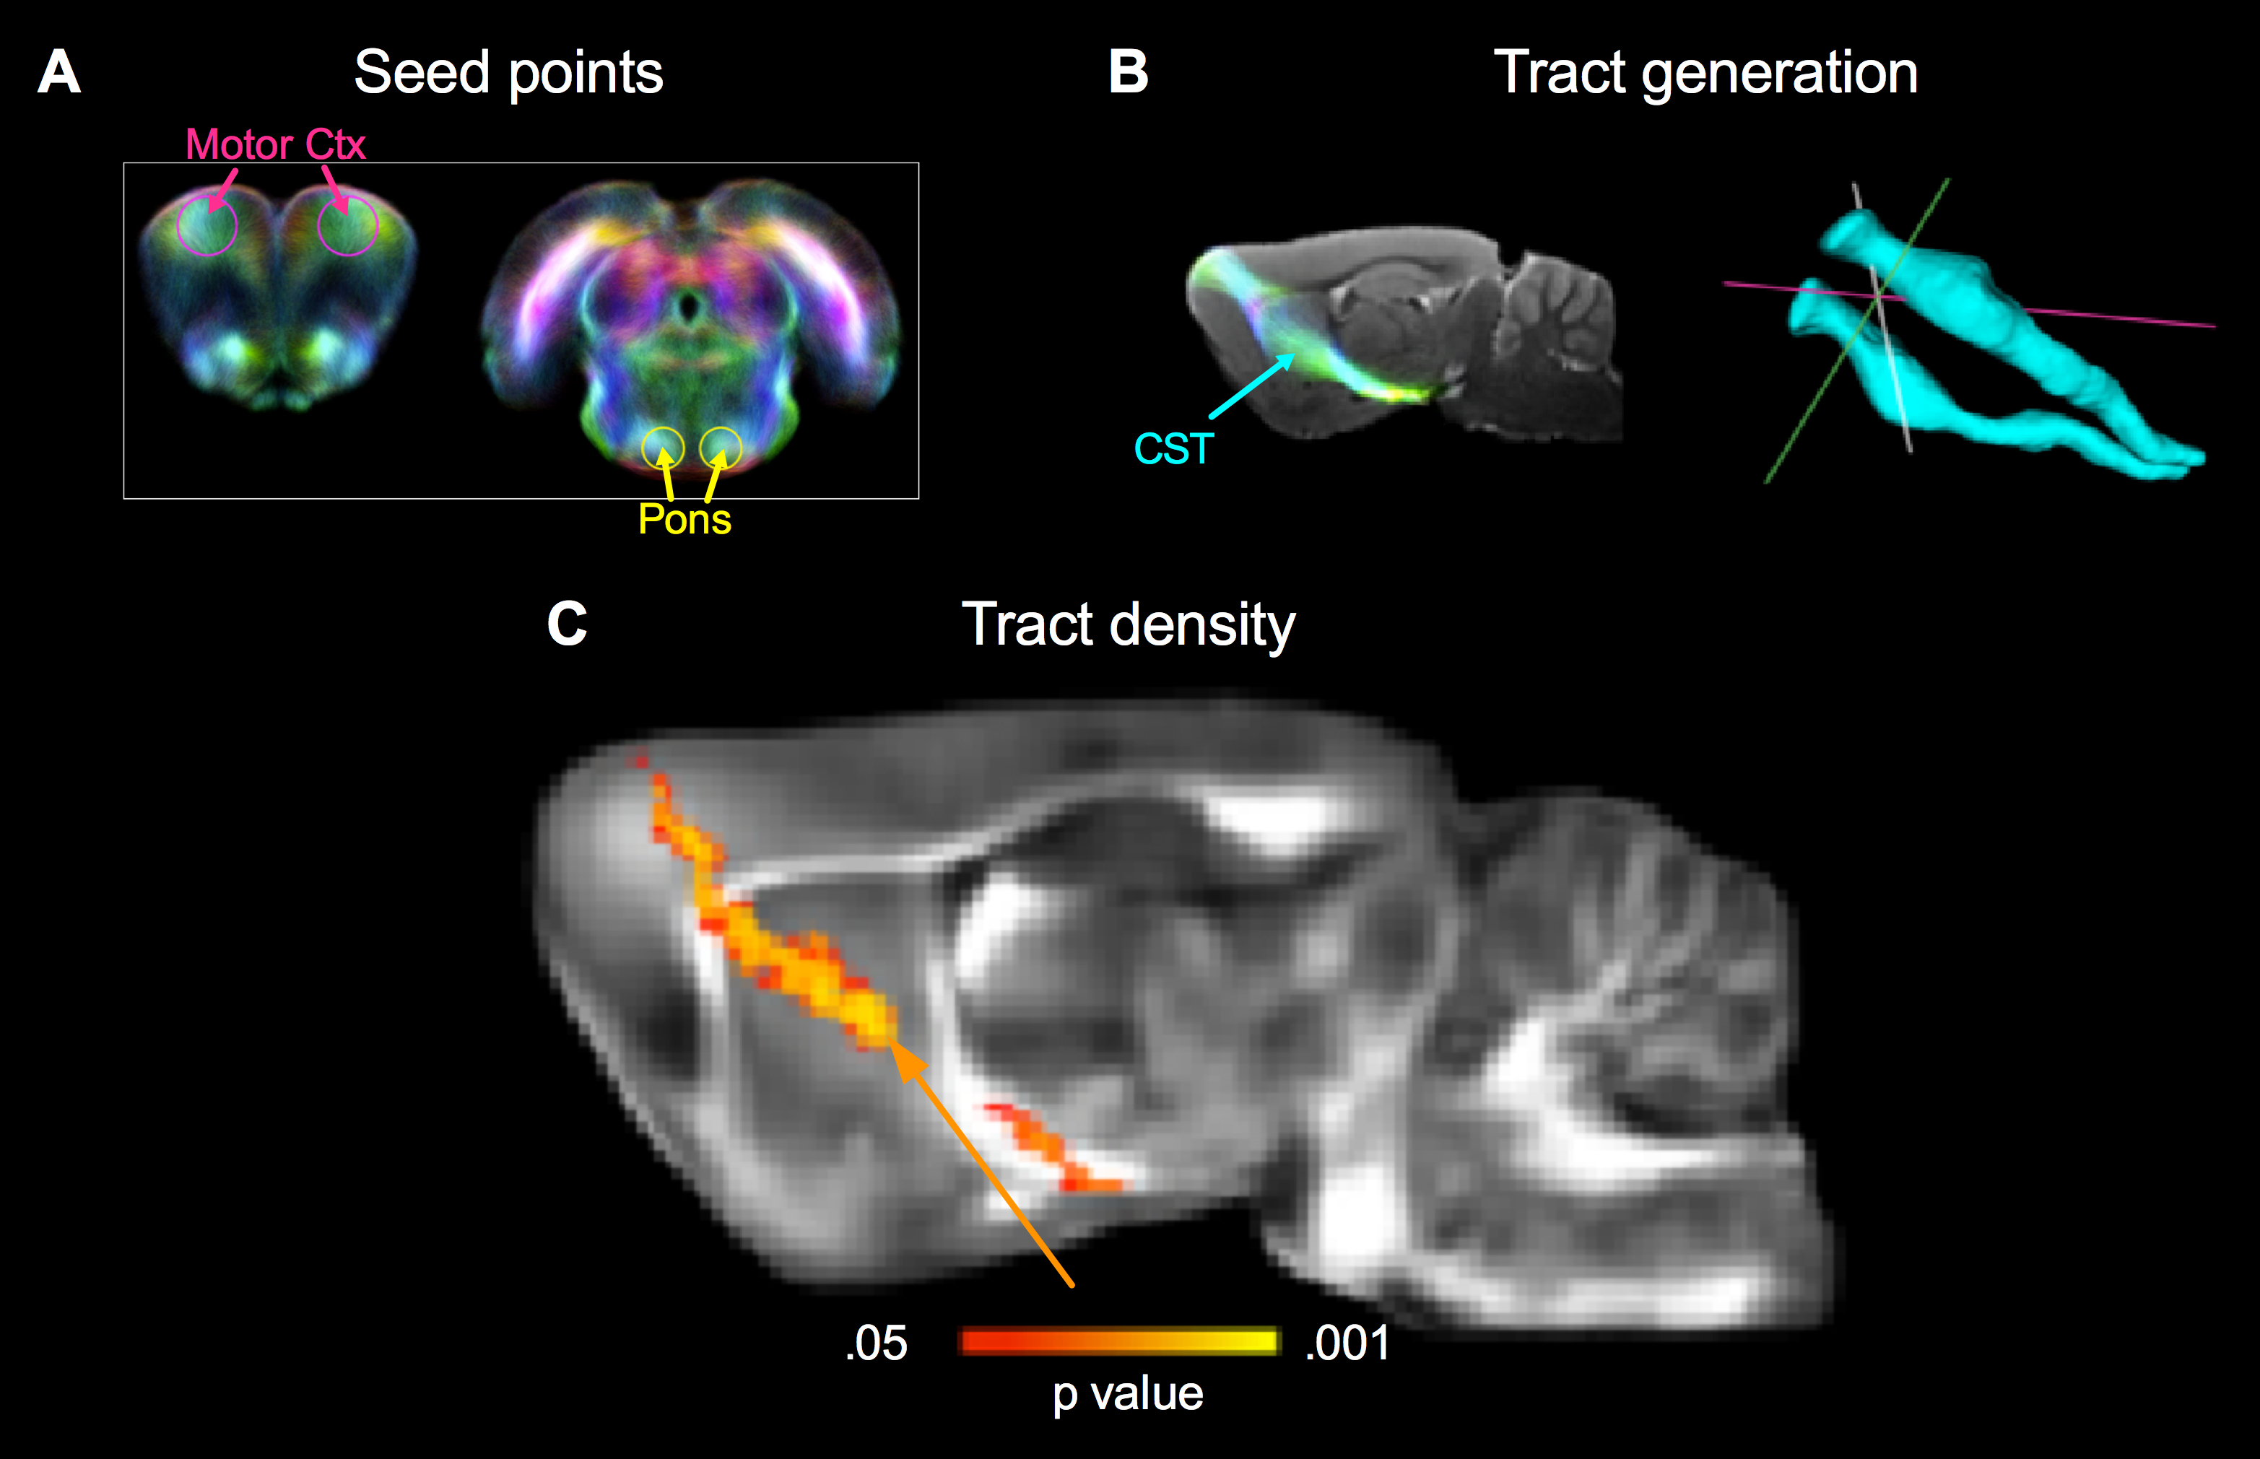

**3.2.2 Experimental Design:** The 1st cohort of 189 adult male Sprague-Dawley rats (63 per study site) will be randomized to severe lateral FPI or sham-operation as shown in Fig. 5, and imaged with in vivo sMRI at 4 time points (2 d, 9 d,1 month, and 5 months post-TBI) as shown in **Fig. 9**. The selection of time points was based on our previous studies showing the most robust progression of pathologies during the 1st 3 months post-TBI22,23. Blood (1.2 ml) will be sampled in the end of each MRI session. In order to diagnose if the rats have developed epilepsy, animals will be continuously (24/7) vEEG monitored with intracortical, intrahippocampal and contralateral cortical epidural electrodes during the 7th month post-TBI (Fig. 6A). Days 1-3 and days 28-30 of the monitoring will be done using wide band acquisition mode to catch pHFOs and rHFOSs. Days 4-27 will be monitored with standard (1-300 Hz) video-EEG (vEEG) to verify the occurrence of spontaneous seizures. At 7 months post-TBI, rats will be perfusion-fixed for ex vivo MRI. After imaging brains will be stored in a biobank for later analysis, if the need arises.



**Figure 9.** Study design: SA2. *In vivo* sMRI will be done at 2 d, 9 d, 1 month, and 5 months post-TBI. Epilepsy phenotype will be determined with 1-month vEEG and wide band EEG done in the beginning and end of the 7th month. In the end, rats will be perfusion fixed to *ex vivo* MRI, and brains stored in brain bank for further analysis if needed.

## 3.3. Structural MRI to analyze focal lesions and damaged pathways

3.3.1. Protocol and data collection:All structural MRI (sMRI) data will be collected in the same session at 4 different time points, each session lasting ~2 h. Anatomical MRI data are collected in 4.7T (Melbourne) or 7T (Kuopio, UCLA) using fast imaging with steady-state precession (FISP) sequence. Microstructural data will be captured using magnetization prepared multi-echo-gradient sequence and DTI. Pulse sequences will be optimized to take into account the field dependency of the relaxation times, and will be confirmed to produce comparable data using standard phantoms and naive animals. As phase imaging is highly field-dependent only data obtained in UCLA and in Kuopio (7T) will be pooled together and data obtained in Melbourne (4.7) will be used to extrapolate findings to human MRI (3T).

3.3.2. MRI analysis: Anatomical high resolution data collected with FISP will be transferred to the IAC for group level morphometric analysis that will be aligned with the methodology in Project 3. Other data analysis will be done locally at each site using identical analysis tools and procedures including Tract-Based Spatial Statistics (TBSS) for DTI data, voxel based morphometry (VBM) in FSL and atlas-aligned ROI analysis. As outcome measures we will assess (a) volumes of the hippocampus, thalamus, remaining ipsilateral cortex, and ventricles, (b) location, number and extent of hemorrhages (**Fig. 10**) as detected in gradient echo and phase images. As outcomes for white matter changes (axonal injury/demyelination) we will assess (c) quantitative MTR values, (d) phase, (e) diffusion anisotropy measures: fractional, linear, planar and spherical, and (f) diffusivities: axial, radial and mean in selected atlas-aligned ROIs (rostrocaudal extent of perilesional cortex, thalamus, septotemporal extent of hippocampus). Quantitative magnetization transfer ratio, scalar DTI parameter, and phase maps will be calculated and ROIs will be drawn in major hippocampal and thalamo-cortical pathways. Finally, particular attention will paid on analysis of co-pathologies (*e.g.*, perilesional iron deposits and odema suggesting ongoing inflammation).

3.3.3. Data analysis*:* (a) ROC analysis: AUC, sensitivity and specificity, and cut-off values will be calculated for each sMRI measure to predict epileptogenesis at a given time point, (b) Logistic regression analysis: all parameters in the database and systematically collected with CDEs (weight, temperature, anesthesia duration etc. in addition to EEG and plasma molecular markers) will be assessed to identify factors which explain the change in sMRI measures.



**Figure 10.** Messori et al. showed using T2 MRI that hemosiderin surrounded with incomplete glial scar is a risk for PTEgenesis (left;34. Right panel shows comparable iron accumulation (hypointensity, magnified in insert) in the perilesional cortex surrounded by a fragmentary hyperintensity, suggestive of incomplete of glial scar.

3.3.4. Anticipated results: vEEG***:***We expect (a) 25% of TBI rats will show >1 spontaneous seizure in the 7th month EEG, (b) interictal EEG changes analyzed on site and in *IAC*will show progression over time. Data from SA2 and SA1will be combined to increase statistical power and assess inter-study variability. ***sMRI:*** We expect that the severity of acute cortical lesion volume in 2 d sMRIs will not differ between TBI epileptic and non-epileptic rats. If it does, the severity of damage will be included as a covariate in analyses. We expect a progressive decrease in the volumes of the ipsilateral cortex, hippocampus and thalamus, which varies between the animals. We expect reduced FA and increased RD in areas of white matter damage on DTI images. We expect to find local signal-void areas in T2* weighted and SW images and characteristic magnetic dipole patterns in phase images, indicative for local hemorrhages with or without signal changes related to neuroinflammation (comparable to *Project 3).* Although the majority of changes will be expected to relate to injury severity and not to epileptogenesis, we expect to find (a) at least 1 pathway specific single or combinatory sMRI biomarker for PTEgenesis, (b) at least 1 multimodal combinatory biomarker(s) for PTEgenesis, after combining sMRI data with EEG (SA1) and plasma molecular analysis (SA3). We expect the occurrence of thalamo-cortical pathway pathology to increase the sMRI biomarker sensitivity and specificity.

3.4. Specific Aim 3: (1) To identify the evolution of abnormalities in plasma proteins and circulating microRNAs which alone or in combination with electrophysiological and imaging markers predict epileptogenesis after TBI with high sensitivity and specificity. (2) To provide a set of candidate biomarkers to be validated in an independent animal cohort in *Project 2* and in human cohort with temporal lobe TBI in *Project 3*.

3.4.1. Hypothesis 3***:*** TBI will induce changes in *plasma proteins and/or microRNAs*, which signal about neuronal/glial degeneration, axonal and dendritic injury, neuroinflammation, and metabolic changes. Change(s) in plasma markers will correlate with the degree of hippocampal and thalamo-cortical damage in sMRI and with some electrophysiological markers. Some plasma markers will be specific for TBI-induced epilepsy rather than TBI alone both in animals and humans.

3.4.1.2. Plasma protein analysis: In our hypothesis-driven approach we will analyze specific changes in 15 plasma proteins, which signal about neuronal and glial degeneration (NSE, neuron-specific enolase; CK-BB, creatine kinase BB; S100B, S100 calcium-binding protein B; GFAP, glial fibrillary acidic protein), neuroinflammation (IL-1B, interleukin-1beta; IL-6, inerleukin-6; IL-8, interleukin-8; TNF-alpha, tumor necrosis factor alpha; INF-γ, interferon gamma), axonal/dendritic damage (MBP, myelin basic protein; Tau, total tau; P-tau, phosphorylated tau; NF-H, neurfilament H), and metabolic changes (ceruloplasmin; HIF-1a, hypoxia-inducible factor 1 alpha)1,4,19. These proteins have been studied in brain and plasma after experimental and human TBI, and shown to signal about the severity of ongoing brain damage and consequent recovery after TBI1,4,19,15,32. Even though the severity of TBI is the most consistent risk factor for PTEgenesis2, these studies have not included epilepsy as an outcome, and thus, the potential of these plasma proteins as biomarkers for PTEgenesis has never been investigated.

3.4.2. Experimental design: Samples will be collected from all animals at 3 study sites both in SA1 and SA2 (**Figs. 6, 9**). For cost reasons, sample selection will be stratified to only a subgroup of animals. Based on previous literature, a useful plasma biomarker should show AUC 0.850 in ROC analysis (p<0.05)52,53. To achieve statistical power in plasma protein biomarker analysis, we will select 10 TBI epilepsy and 27 TBI no-epilepsy rats from the total cohort of 21 TBI epilepsy and 63 no-epilepsy cases, which show comparable severity of damage in sMRI. Analysis will be done from all 5 time points.

3.4.2.1. Blood collection: Blood (1.2 ml) will be collected in from tail vein (<http://www.nc3rs.org.uk/bloodsamplingmicrosite/page.asp?id=420>) of lightly isoflurane-sedated rats at 7 d before TBI/sham operation, and at 2 d, 9 d, 1 month, and 5 months post-TBI. Blood cells and plasma will be separated (half for plasma protein extraction – clotting to be done at room temperature, half for microRNA extraction – clotting at +4oC), and stored at -70oC at each study site.

3.4.2.2. Plasma protein analysis: Plasma will be shipped to IAC (Dr. Agoston) for analysis of 15 protein markers (see above) using reverse phase protein microarray assay1. The Excel sheet containing the plasma concentrations of each marker in each animal at different time points will be sent to each study site and IAC.

3.4.3. Data analysis:The 15 plasma protein levels will be combined with data on electrophysiology and imaging, and statistically analyzed: (a) ROC analysis: AUC, sensitivity and specificity, cut-off values to predict epileptogenesis alone or in combination with other modalities at different time points, (b) Logistic regression analysis: To reveal non-epileptogenesis related factors affecting plasma protein levels, we will assess the effect of different variables (time of collection, weight, rectal temperature, anesthesia duration etc. in addition to EEG and sMRI) on protein markers.

3.4.4. Expected results:(a) at least 1 of 15 plasma proteins will have AUC >0.850 to PTEgenesis, (b) >1 plasma protein markers will show AUC >0.850 to PTEgenesis when combined to one EEG or one sMRI marker.

3.5. Plasma microRNA analysis**:** In our *unbiased approach*, we will analyze microRNA-seq and apply advanced bioinformatics tools to discover novel candidate plasma biomarkers, including pathologies not revealed by plasma protein markers (SA3.1). Target analysis of regulated miRNA will also inform us of novel epileptogenic mechanisms. MicroRNAs (miRNA) are short (20-24 nucleotide) single-stranded non-coding RNAs that regulate gene expression at post-transcriptional level3. A single miRNA can target hundreds of mRNAs, and thus, impact translation of multiple protein products. Expression of some miRNAs is considered to be brain-specific, which increases their potential as brain-specific biomarkers36. The great inter-species conservation of miRNAs makes extrapolation of experimental data to human TBI feasible55. The stability of circulating miRNAs, ease of collection, and sensitivity of detection using RT-PCR make miRNAs as attractive clinically relevant targets for biomarker discovery for PTEgenesis.

3.5.1. Previous and Preliminary results:Two recent studies evaluated circulating miRNAs as biomarkers in human epilepsy. Wang et al. 53 measured serum miRNA levels in 30 people with epilepsy and 30 controls, and validated the selected miRNAs in a larger cohort of cases. Six miRNAs were de-regulated in epilepsy patients and ROC analysis revealed that miR-106b-5p had the highest sensitivity and specificity for a diagnosis of epilepsy (AUC 0.882). In another study, Wang et al.52 evaluated 77 drug-resistant and 81 drug-responsive epilepsy patients as well as 85 healthy controls. Five miRNAs were de-regulated in drug-resistant patients. In ROC analysis, miR-301a-3p had the best diagnostic values for drug-resistant epilepsy (AUC 0.893). Using lateral FPI model of TBI Truettner al.50 reported changes in 15 miRNA in the cortex at 24 h post-injury which were modulated by hypothermia. Interestingly, one study has reported AEG effects of hypothermia in FPI model13. Our recent miR-seq analysis at 3 months post-TBI demonstrated long-lasting regulation of miRNAs in the perilesional cortex and thalamus (Pitkänen; unpublished).

Our other analysis indicated that the plasma level of brain-specific miR-124 peaked at 2 d post-TBI and associated with an increased miR-124 in the ipsilateral hippocampus (not shown). ROC analysis of our data revealed plasma miR-124 as a sensitive and specific biomarker to diagnose TBI (**Fig. 11**). Changes in plasma miRNAs have also been observed in human TBI. Redell et al.42 found a reduction in miR16, and miR92a while miR765 increased after severe TBI. After mild TBI, miR16 and miR92a increased and miR765 was unchanged. These data support the notion that miRNA profile changes may provide an objective, quantitative means to stratify severity of injury. Importantly, plasma miRNA changes after TBI are different from those in epilepsy, suggesting that changes in plasma miRNA signature can differentiate epilepsy from TBI TBI, and serve as potential biomarkers for PTEgenesis.



**Figure 11.** Plasma miR-124 differentiates TBI from controls after lateral FPI (unpublished).

3.5.2. Experimental design: For plasma miR-seq analysis, we will analyze 10 sham-operated controls (to assess the increase/decrease of change), 10 TBI epilepsy rats used for protein analysis (see above), and 10 randomly selected TBI no-epilepsy rats from the 27 cases used for protein analysis with comparable 9-d sMRI pathology. miR-seq analysis will be done from the 9 d samples only. The time point was selected to (a) avoid the most acute non-specific injury-related changes, but still (b) probe the miRNA changes at early epileptogenesis stage which have a time-window of about 10 days to be applied in clinic.

3.5.2.1. Plasma microRNA analysis***:*** For plasma microRNA analysis, selected samples will be shipped to Kuopio that coordinates the shipping of samples for miR-seq (outsourced, current offer from Exiqon, Denmark). The contract includes quality control, mapping of reads to genome, identification of microRNAs (including novel miRNAs), comparison of treatment groups, gene ontology analysis, and biological interpretation. The results on Excel datasheet and raw data on hard disc will be send to *IAC* to become openly available.

3.5.3. Data analysis:miR-seq data will be further analyzed in Kuopio using (1) miRWalk to list miRNA targets and (2) Ingenuity Pathway Analysis (IPA) to derive molecular networks from miRNA targets to identify (a) protein pathways linked to the plasma protein networks analyzed in SA3.1, (b) to discover novel regulated protein networks. To wet lab validate the miR-seq data and assess the miRNA biomarker sensitivity and specifcity, we will perform RT-qPCR of the 3 most regulated miRNAs (and 1 house-keeping gene) in animals used for miRNA-seq analysis and also of the remaining TBI epilepsy (total 21) and TBI no-epilepsy (total 63) rats in Kuopio (TaqMan Small RNA Assays). Our blood bank allows extrapolation of analysis to an independent cohort of 21+63 rats, using additional funding to be applied. We will perform **(a)** ROC analysis: AUC, sensitivity and specificity, and cut-off values for each miRNA to predict epileptogenesis will be calculated at a given time point, **(b)** Logistic regression analysis: all parameters in the database and systematically collected with CDEs (including weight, temperature, anesthesia duration etc. in addition to EEG and sMRI) will be assessed to identify factors which explain the change in miRNA values.

3.5.4. Expected results***:* (a)** a total of 10-15 miRNAs are differentially regulated at 9 d post-TBI between TBI epilepsy and TBI no-epilepsy groups, **(b)** from these, at least 1 miR shows sensitivity and specificity >0.850 to PTEgenesis, **(c)** >1 miRs shows sensitivity and specificity >0.850 to PTEgenesis when combined to >1 EEG or sMRI marker(s), **(d)** bioinfomatics analysis reveals a link between at least protein targets of 1 regulated plasma miRNA and 1 regulated protein analyzed in SA3.1, **(e)** bioinformatics analysis of plasma miRNAs provides evidence of changes in at least 5 brain-specific molecular pathways for further hypothesis-driven analyses of mechanisms and potential biomarkers of PTEgenesis.

3.6. Deliverables For Specific Aims 1-3***:*** Validated (1) Plasma molecular, (2) Electrophysiological, (3) Imaging, (4) Combinatory biomarker panels to predict epileptogenesis and treatment response in preclinical and clinical AEG studies.

3.7. The next step***:*** Biomarker panels discovered in *Project 1* will be provided to *Project 2* to (a) be validated in an independent cohort of animals and (b) to assess whether they predict the treatment response in preclinical AEG trial (years 4-5 Project 3). It will also be compared to findings in clinical *Project 3* to validate the animal biomarker panel for clinical use (year 3, *Project 1*).

# 4. Specific Methods

4.1. Harmonization of data collection, analysis, and procedures: Common Data Elements (CDEs) and Case Report Forms (CRFs) designed for preclinical (http://www.ninds.nih.gov/research/tbi/index.htm) and clinical (https://commondataelements.ninds.nih.gov/TBI.aspx#tab=Data_Standards) TBI and pre-clinical epileptogenesis studies (EPITARGET CDEs <http://www.epitarget.eu/>) will be utilized to harmonize the methodologies between 3 preclinical study sites and between pre-clinical and clinical studies. CDEs and CRFs will be finalized for *Project 1* via weekly teleconferences during the first 3 months. EEG and MRI instrumentation in different study sites is tabulated in Facilities enclosure. **Animals.**Adult male 12 wk old Spraque-Dawley rats (weight 325 ± 25 g at the beginning) will be purchased from a local vendor. They will be randomized into different study groups as shown in **Fig. 6**. Exclusion criteria: >15% weight loss during first post-TBI weeks, loss of electrode headset more than once, poor well-being assessed using standard Animal Center protocol. **FPI injury.** 1 wk after arrival, rats are anaesthetized, placed in a Kopf stereotactic frame, skull is exposed, and periosteum extracted. A circular craniotomy (Ø 5 mm) is performed over the left posterior convexity (center AP-4.5, L2.5; **Fig. 6A**), leaving dura intact. The edges of craniotomy are sealed with a modified Luer-Lock cap filled with saline. Calvaria is covered with dental acrylate. Severe lateral FPI will be induced 90 min after anaesthesia induction by connecting the rat to a fluid-percussion device27,33,44. The mean severity of the impact (≈2.8-3.0 atm) is adjusted to produce severe TBI (≈30% mortality). Control animals receive anesthesia and all surgical procedures without FPI. Would edges are covered with antibiotic cream and rats treated with analgesics. Sham-operated controls will undergo all procedures except the impact.

4.2. Electrode implantation for vEEG follow-up and monitoring**:** Immediately after FPI or sham-injury (SA1) or at 6 months (SA2), rats will be anesthetized with 2.0% isoflurane on a heating pad and fixed in the stereotaxic frame. After cleaning with Betadine/70% alcohol, 0.5 mm holes will be drilled to secure the bipolar electrodes around the perilesional cortex (coordinates: see **Fig. 6A**) and contralaterally (an epidural screw). Reference and ground electrodes are positioned above the cerebellum. After fixation of the connector head cap, wound edges are infiltrated with 0.5 % Marcaine, and closed with a wound clip. Rats will be treated with analgesics. For the 1st 2 post-operative days rats receive 0.9% NaCl to prevent dehydration. If any inflammation appears, neosporin ointment will be applied to wound edges. We will regularly monitor (a) general well-being of animals using the standardized form provided by Animal Center, (b) weight (once per week), (c) rectal temperature (once per week). Equipment and details of vEEG monitoring are as described previously (Kuopio**26**; Melbourne**44**; UCLA**8**). At night, monitoring is done under infrared light.

4.3. Standard vEEG to diagnose epilepsy:Experiments will be carried out under freely moving conditions in animal’s own cage. Shorter term wide band EEG recording and analysis has been described in SA1. Standard video-EEG (vEEG) (0.1-300 Hz; sampling rate 1-2 kHz/channel) will be monitored continuously for 1 month (**Figs. 5, 9**).The recording montage will consist of bipolar intracortical and intrahippocampal electrodes and a contralateral epidural electrode (stainless steel screws, 0.5 mm OD) positioned as shown in **Fig. 6A**). The likelihood for correctly diagnosing epilepsy, if it exists, was calculated assuming that seizure appearance has exponential distribution, and expected frequency based on our previous published experience is 0.2 seizures/d35,40,44. The likelihood that we will detect seizures during the 4-wk monitoring, if they exist, is 99.75%. Even if the seizure frequency will be 0.1seizures/d, the likelihood would still be 95.02%. Digitized EEG recordings will be screened on computer screen by an experienced technician, blinded to the experimental group, and seizures and epileptiform discharged identified. An electrographic seizure is defined as high-amplitude rhythmic discharges that represents a new pattern of activity (repetitive spikes, spike-and-wave discharges, and slow waves) that last ≥10 s. Epileptic events occurring with an interval < 5 s without the EEG returning to baseline are defined as belonging to the same seizure. Visual screening of EEGs will be stopped after the 1st electrographic seizure is detected, hallmarking epilepsy diagnosis17. The behavioral severity of seizures will be checked from time-locked video (to confirm that the EEG pattern was not artefact related, *e.g.*, due to grooming). We estimate that instead of screening 2 x 35 TBI rats with 30-d or 60 d EEGs per site (total 3 150 d ≈ 75 600 h of EEG), on average only 50% of the collected EEG will need to be analyzed before the 1st seizure is detected. Since an experienced technician can assess a 1 wk ≈ 168 h of EEG in 1 d, we calculate that analysis of EEG will take 225 working days (9 months) per site. EEG data files will be sent to the *IAC*to be assessed using unsupervised analysis tools.

4.4. MRI Hardware ***-*** Dedicated small animal MRI systems using similar hardware (decoupled volume transmit RF-coil/ quadrature or 4 channel receiver coil; actively shielded gradient coils) and operating at 4.7T or 7T Bruker consoles operating under paravision 6.0, will be used. Identical pulse-sequences and harmonized imaging parameters (taking into account field dependent differences in relaxation, magnetic susceptibility and S/N) will be used to produce comparable data. Use of different field strengths allows interpolation of the results to clinical MRI field strengths to better estimate translational value of the results. As quality control, the imaging protocols will be tested using standard phantoms and S/N, image homogeneity and stability are compared.

4.5. Animal anesthesia and monitoring during imaging: During MRI experiment rats will be anesthetized with isoflurane (1.5-2%) inhalation anesthesia in 30%/70% O2/N2 carrier gas mixture. For monitoring of level of anesthesia and physiology, MRI compatible rectal temperature probe, breathing sensor pad and pulse oximetry sensor (for heart rate and blood oxygenation) will be used.

**4.6.** Anatomical, MT and SWI/phase imaging: Anatomical images will be acquired using 3D-FISP pulse sequence with following parameters: spatial resolution 160x160x160 µm3, flip 15 deg, TR 8 ms, TE 4 ms, bandwidth 50 kHz, 4 averages. To acquire data for T2*, unwrapped phase and SWI maps and magnetization transfer maps, 3D-multiecho GRE (MGRE) will be used. The MGRE parameters will be: TR = 100 ms (depending on field strength), 12-16 echoes with first echo at 2.3 ms, time between echoes 3.1 ms, last echo at 36.4-48.8 ms, flip angle = 18-23, resolution of 160 x 160 x 160 µm3. Data set will be acquired with and without MT preparation consisting of Gaussian pulse with a length = 20 ms and amplitude = 500 Hz at 3000 Hz off-resonance repeated every four acquisitions. Anatomical MRI data is converted to DICOM format and transferred to LONI for further analysis. The magnetization transfer ratio (MTR) maps will be calculated and the phase maps will be high-pass filtered to remove spatially slow field fluctuations. SWI maps will be calculated by combining phase and magnitude information.

4.7. Diffusion tensor MRI:data for microstructural characterization and fiber tracking will be acquired using a segmented 3D-EPI sequence (TE= 28 ms, TR = 1000-1200 ms, 2-4 segments) with outer volume suppression. An area of 24 × 15 x 15 mm3 will be covered with 96×60x60 points resulting in a spatial resolution of 250×250x250 μm3. The dataset will contain 4 b0 images and 42 diffusion directions with a b-value of 2800 s/mm2. We will extract and analyze most commonly used scalar DTI parameters (anisotropies: fractional, linear, planar and spherical; diffusivities: axial, radial and mean) in selected brain areas to estimate white matter integrity. Data analysis will be done in Matlab using ExploreDTI analysis package and in-house written codes.

4.8. Diffusion MRI tractography***:*** Structural connectivity between regions of interest (ROIs) will be assessed using probabilistic tractography tools of FSL (<http://fsl.fmrib.ox.ac.uk/fsl/fslwiki/FSL>) in addition probabilistic whole-brain fibre-tracking are performed using the MRtrix software package16,49 with orientations sampled from the constrained spherical deconvolution and seeded at random within the whole brain mask16. The total numbers of tracks and track densities for internal capsule, corpus callossum, fimbria fornix and perforant pathway are calculated for each animal.

4.9. Ex vivo MRI and Histology:Animals will be intracardially perfused with 0.9% NaCl (2 min) and 4% paraformaldehyde (30 min). Brains will be postfixed in the same fixative. For *ex vivo* MRI brains will be placed in the plastic sample tube filled with perfluoronated liquid (Fomblin). *Ex vivo* MRI will be carried out using the same protocols as i*n vivo*. After that brains will be cryoprotected in 20% ethyleneglycol in 0.02 M KPBS, frozen in dry ice, and stored at -70oC.

# 5. Statistical analysis

5.1. Power analysis: for sample size estimation and strategy for assessing the sensitivity and specificity of a given marker as a biomarker of PTEgenesis. To show that AUC of 0.800 (aimed value) in ROC analysis differs significantly from 0.600 (0.8 power), we will need 21 TBI rats with epilepsy and 63 TBI rats without epilepsy (expected rate of epilepsy 25% within 7 months follow-up; an independent diagnostic marker is one spontaneous electrographic seizure, indicating that epileptogenesis has happened in a given animal)(MedCalc15 software). Our strategy to search combinatory biomarkers will be to use logistic regression analysis (dependent variable: epilepsy; explanatory variable: different markers). Analysis will take into account age and injury volume. Consequent ROC analysis will be done using the predicted value obtained in logistic regression analysis. Another strategy will be to use the 1st component of Principal Component Analysis in ROC analysis. The animal numbers above will also be high enough to show the difference in measured parameters between TBI epilepsy vs. TBI no-epilepsy groups. Namely, based on our preliminary sMRI22,23 data and literature review of plasma protein and microRNA biomarkers52,54, we expect that the minimum mean difference between TBI epilepsy and TBI no-epilepsy groups is 0.15 (15%) and SD 0.15 (15%) normalized units. Based on these values, sample size of 11 epileptic and 33 non-epileptic rats will provide 80% power at a significance level of p<0.05 (MedCalc15 software). If the plasma biomarker AUC will be >0.850, our sample size will allow a subgroup analysis within the cohort [*e.g.,* rapidly progressing (8 epilepsy, 24 no epilepsy) vs. slowly-progressing (8 epilepsy, 24 no epilepsy) MRI-pathology groups].

# 6. Potential problems for each Specific Aim, with possible solutions

6.1. Harmonization of experiments between the 3 study sites **(Kuopio, UCLA, Melbourne):** We will use established methodology to induce temporal lobe TBI27,31,33. As aiming to perfect similarity in all experimental procedures between the 3 study sites would likely fail30, we will acknowledge the variability and take advantage However, this aligns with human TBI subpopulations which are not genetically homogeneous either. Importantly, we will control the critical aspects of the study between inter-site experimentation as follows: (i) we will harmonize the EEG and MRI hardware and their use as tabulated in *Facilities enclosure*, and (ii) we will use CDEs and fill out CRFs to collect data to statistically analyze the possible effects of procedures and their site-dependency on outcome, (iii) we will conduct interim analysis of injury severity (<48 h mortality, lesion volume and location in 2 d MRI) between the sites after completing the 1st set of animals, (iv) we will have monthly teleconferences to discuss the progress and possible problems in studies. In particular, technicians/postdoc doing the hands-on work will be included in teleconferences, (v) if data between the sites differs (p<0.05), we will include study site as a covariate in statistical analysis. We will use this approach also to control experimentation between animal cohorts investigated within each study site.

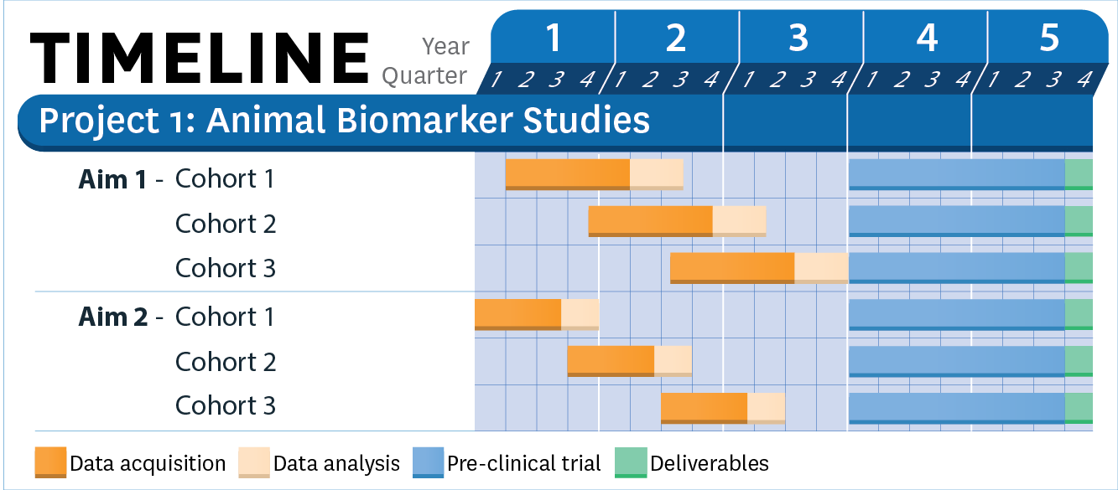6.2. Specific Aim 1 – electrophysiology: The long follow-up with multiple intracerebral and epidural electrodes increases the risk of losing headsets. We will re-implant them once if the animal’s condition allows. If necessary, we complement the series with additional animals to maintain the statistical power of the study.To control the possible electrode-related injury, we will assess the electrode-related signal changes from *ex vivo* MRIs.

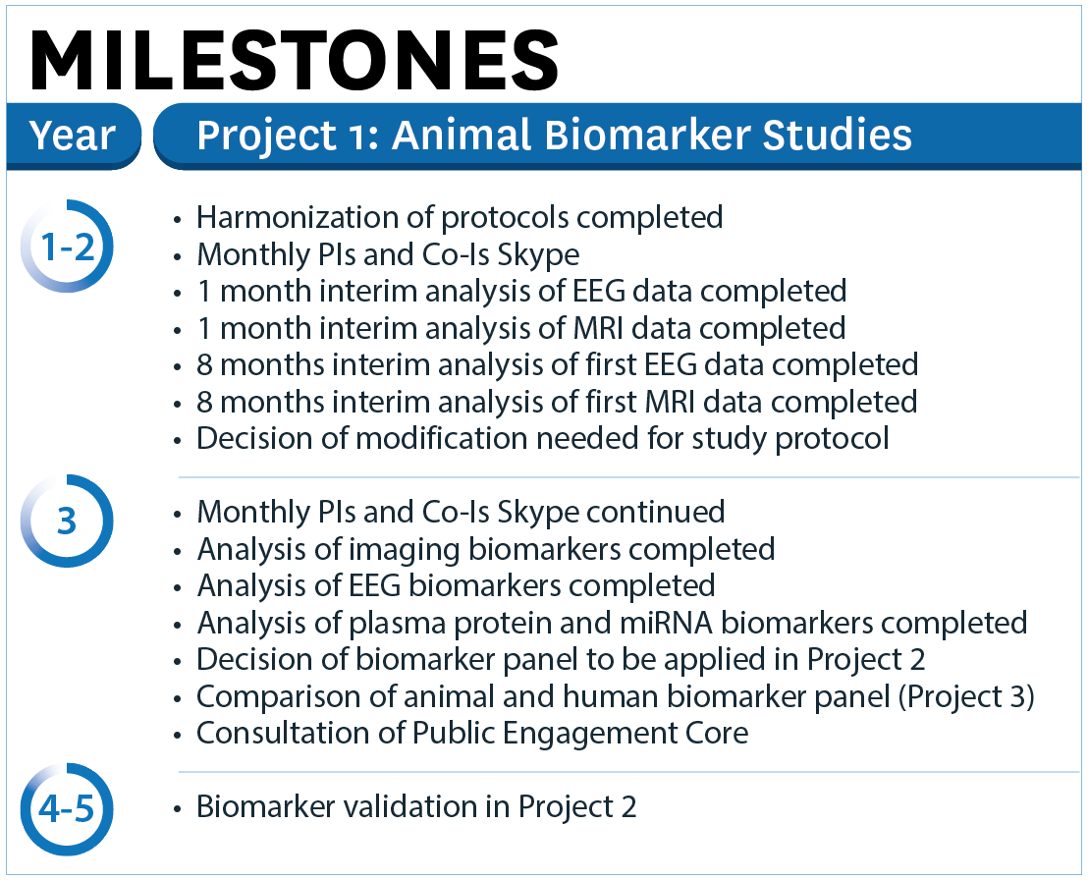6.3. Specific Aim 2 – sMRI:(a) If the percentage of rats that develop spontaneous seizures is lower than anticipated, we will record additional TBI rats to reach our estimated sample size. (b) Since abnormal high-voltage spindles (HVS) can occur in aged Sprague-Dawley rats25,37, we will monitor age-matched sham-operated controls, and include aging-related HVS counts as a covariate in statistical analysis. (c) Animal can undergo epileptogenesis even not showing seizures during 1-month vEEG which results in likely underestimation of epilepsy in a given cohort. We compare the data from SA2 to that in 12-months follow-up in SA1, and acknowledge the false negative rate at 7 monsths post-TBI.

6.4. All Aims:Repeated anesthesia can modify epileptogenesis. However, we will estimate the prevalence of epilepsy from the 7th month recording in SA1 (no long MRI-related anesthesias) and compare that to data from SA2 (4 long anesthesias). If we find a difference, number of anesthesias will be included as a covariate in statistical analysis.

# 7. timeline

# 8. milestones